I received 5/100 on this assigment.
This is the grade rubric. I hope this can help you to make some change
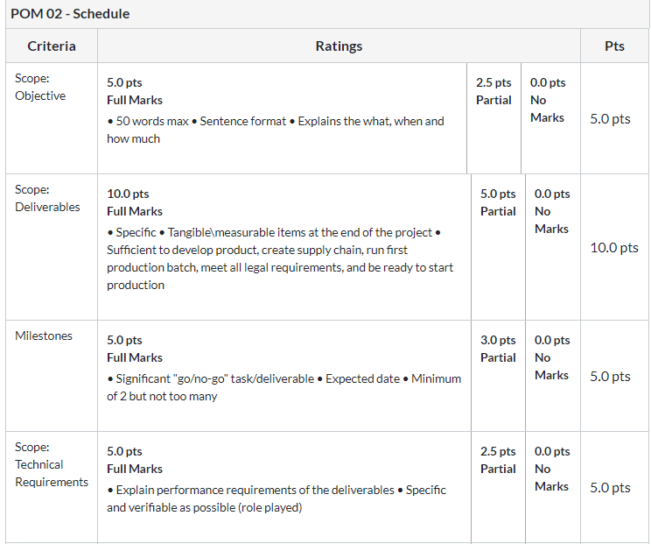
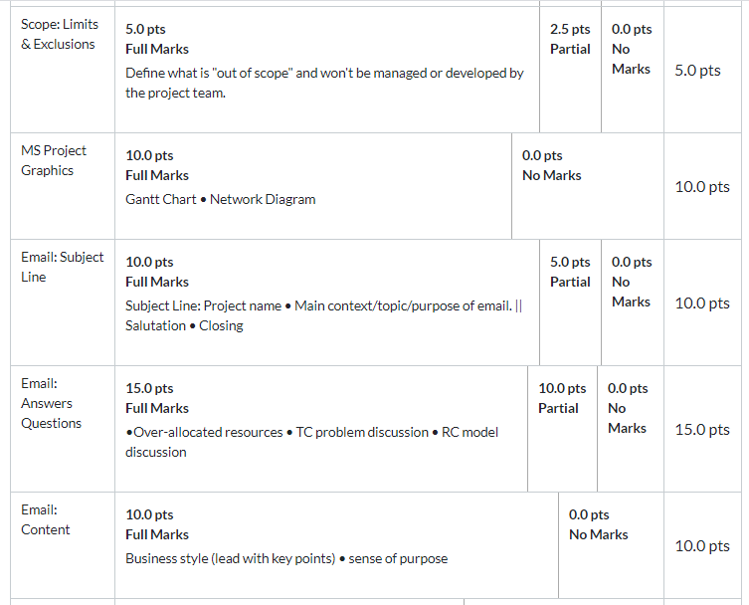


Big Kola Company Project Part 2

Preliminary Update
The project task will have resources such as human resources attached. Each task will have at least one task or more attached. The resources in the project include marketing staff, R&D, Engineering, purchasing, quality engineers, designers, legal staff, and production. The resources are essential in the implementation of the project. The resource can have one of the more units that are assigned to a specific task.
The MS project application indicates over-allocated resources automatically. The over-allocated resources in the project are R&D and Legal. The over-allocation must be cleared for the project to run effectively. Over allocation can be solved by leveling of the task that is not in a critical path by rescheduling the task date without changing the completion date. Solving overallocation for tasks in the critical path requires that assigning more resources or increasing the completion date (Helmers, 2015)
The cost rate for each resource is also included in the project. The cost is normally in rates per hour for human resources in the project. The rate may vary for the normal hours and that of overtime. The project manager can know the estimated cost of the resources in the project such amount that can be used to pay all the human resources.

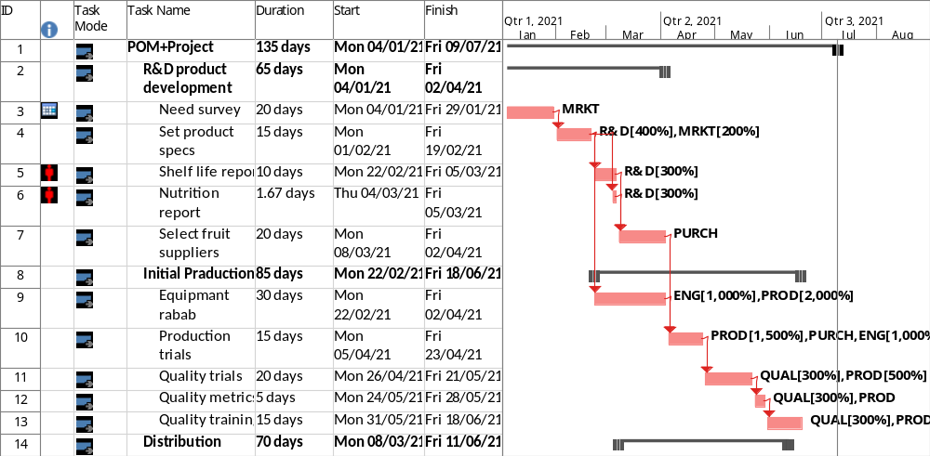

Part 2 Question
- Which if any of the resources is overallocated? R&D and Legal resources are over-allocated
- Assume that the project is time constrained and try to resolve any over allocation problems by leveling within the slack. What happens? R&D is clear
- What is the impact of leveling within slack on a sensitive network? The resource in sensitive slack is not leveled hence the resources remain over-allocated.
- Assume the project is resource-constrained and resolve any overallocation problems by leveling outside of slack. What happens?
The over-allocated resources will be scheduled for more days; the end date will increase. The overallocation can be solved also by increasing the units of the number of resources.

Reference
Helmers, S. A. (2015). Microsoft Visio 2016 Step By Step: MS Visio 2016 Ste by Ste_p1. Microsoft Press.

